63 Physics - Fluid Simulation
Fluid Simulation 1
Workflow 2
Fluid Types 2
Common Options 2
Animated Mesh/Export 2
Volume Initialization Type 2
Fluid Domain 3
The Domain Object 3
Options 4
Domain World 6
Domain Boundary 8
Domain Particles 8
Fluid Object 9
Fluid Obstacle 10
Fluid Inflow / Outflow 11
Inflow 11
Outflow 11
Fluid Particle 12
Fluid Control 13
Description 13
Examples 13
Options 14
Baking 14
Bake Button 15
Bake directory 15
Notes 15
Fluid Appendix 16
Hints 16
Limitations & Workarounds 16

Fluid Simulation

Fluid physics are used to simulate physical properties of liquids especially water. While creating a scene in Bforartists, certain objects can be marked to participate in the fluid simulation. These can include but not limited to, being a fluid or as an obstacle. For a fluid simulation you have to have a domain to define the space that the simulation takes up. In the domain settings you will be be able to define the global simulation parameters (such as viscosity and gravity).
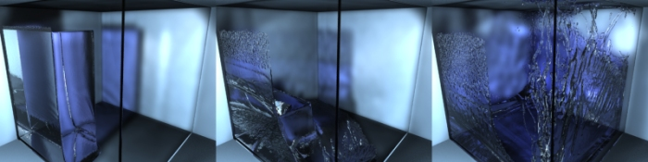
Example of Fluid Simulation

Workflow
In general, you follow these steps:
- First you want to set the simulation domain,
- Next set the fluid source(s), and specify there physical properties,
- In some cases you may want to set other objects to Control the Flow of the fluid,
- You can also depending on your scene add other objects related to the fluid, like:
  - Obstacles,
  - Particles floating on the fluid,
- And lastly you must Bake the Simulation.
Tip
Baking is done on the Domain object!
When you calculate the fluid simulation, you bake the simulation on the domain object.
For this reason:
- All the baking options are visible only when selecting the Domain Object,
- Baking options are explained in the the baking section of the Domain manual page.

See also
To know more about simulating fluids in Bforartists you can read the fluids appendix. Their you can find the limitations and workarounds, and some additional links.

Fluid Types

Common Options

Animated Mesh/Export
Click this button if the network is animated (eg . Deformed by an armature , shape keys (shape keys) or lattice). It can become very slow and is not necessary if the network is animated IPO position and rotation (ie only object transformations).

Volume Initialization Type
A common option amoung the different fluid types is Volume Initialization.
Volume
The inside of the object is initialized as fluid all . This works only if the closed mesh .
Shell
It is initialized as a thin fluid layer of the surface of the mesh . This can also be used in the mesh open.
Both
It is a state , such as the sum of the Volume and Shell. This also must be a closed mesh.
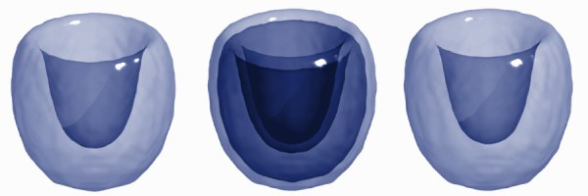
Example of different types of initiation of volume

Fluid Domain

The Domain Object
The bounding box of the object serves as the boundary of the simulation. All fluid objects must be in the domain. Fluid objects outside the domain will not bake. No tiny droplets can move outside this domain; it’s as if the fluid is contained within the 3D space by invisible force fields. There can be only a single fluid simulation domain object in the scene.
The shape of the object does not matter because it will always be treated like a box (The lengths of the bounding box sides can be different). So, usually there won’t be any reason to use another shape than a box. If you need obstacles or other boundaries than a box to interfere with the fluid flow, you need to insert additional obstacle objects inside the domain boundary.
This object will be replaced by the fluid during the simulation.

Tip
Baking is done on the Domain object
When you calculate the fluid simulation, you bake the simulation on the domain object. For this reason all the baking options are visible only when selecting the Domain Object.
For baking options, see Baking.

Options
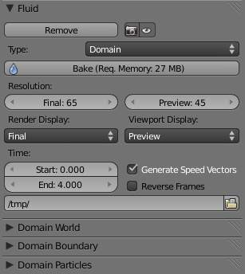
The fluid simulation options with Domain selected
Bake button
For baking options, see Baking.
Resolution
Render resolution
The granularity at which the actual fluid simulation is performed. This is probably the most important setting for the simulation as it determines the amount of details in the fluid, the memory and disk usage as well as computational time.
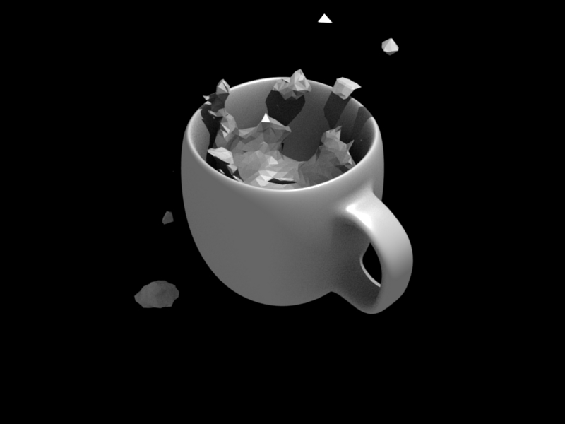  10cm mug at Resolution 70. | 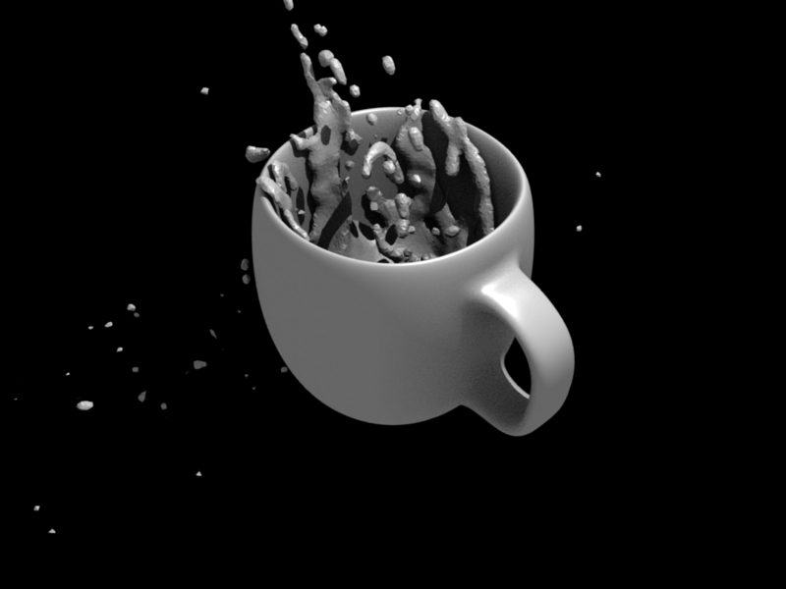  10cm mug at Resolution 200.
Note that the amount of required memory quickly increases: a resolution of 32 requires ca. 4MB, 64 requires ca. 30MB, while 128 already needs more than 230MB. Make sure to set the resolution low enough, depending on how much memory you have, to prevent Bforartists from crashing or freezing. Remember also that many operating systems limit the amount of memory that can be allocated by a single process, such as Bforartists, even if the machine contains much more than this. Find out what limitations apply to your machine.

Note
Resolution and Real-size of the Domain
Be sure to set the resolution appropriate to the real-world size of the domain (see the Realworld-size in the Domain World). If the domain is not cubic, the resolution will be taken for the longest side. The resolutions along the other sides will be reduced according to their lengths (therefore, a non-cubic domain will need less memory than a cubic one, resolutions being the same).

Preview resolution
This is the resolution at which the preview surface meshes will be generated. So it does not influence the actual simulation. Even if “there is nothing to see” in the preview, there might be a thin fluid surface that cannot be resolved in the preview.
Display quality
How to display a baked simulation in the 3d view (menu Viewport Display) and for rendering (menu Render Display):
Geometry
use the original geometry (before simulation).
Preview
use the preview mesh.
Final
use the final high definition mesh.
When no baked data is found, the original mesh will be displayed by default.
After you have baked a domain, it is displayed (usually) in the Bforartists window as the preview mesh. To see the size and scope of the original domain box, select Geometry in the left dropdown.
Time
Start
It is the simulation start time (in seconds).
This option makes the simulation computation in Bforartists start later in the simulation. The domain deformations and fluid flow prior to the start time are not saved.
For example, if you wanted the fluid to appear to already have been flowing for 4 seconds before the actual first frame of data, you would enter 4.0 here.
End
It is the simulation ending time (in seconds).

Tip
Start and end times have nothing to do with how many frames are baked
If you set Start time to 3.0, and End time to 4.0, you will simulate 1 second of fluid motion. That one second of fluid motion will be spread across however-many frames are set in the Anim panel (Scene context –> Render sub-context –> Anim and Output panel).
This means, for example, that if you have Bforartists set to make 250 frames at 25 fps, the fluid will look like it had already been flowing for 3 seconds at the start of the simulation, but will play in slow motion (one-tenth normal speed), since the 1 second fluid sim plays out over the course of 10 video seconds. To correct this, change the end time to 13.0 (3.0 + 10.0) to match the 250 frames at 25 fps. Now, the simulation will be real-time, since you set 10 seconds of fluid motion to simulate over 10 seconds of animation. Having these controls in effect gives you a “speed control” over the simulation.

Generate Speed Vector
If this button is clicked, no speed vectors will be exported. So by default, speed vectors are generated and stored on disk. They can be used to compute image based motion blur with the compositing nodes.
Reverse fluid frames
The simulation is calculated backward
Bake directory
For baking options see Baking.

Domain World
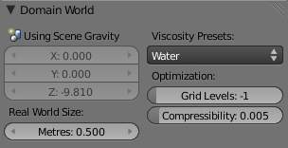
The Domain World options.
Viscosity
The “thickness” of the fluid and actually the force needed to move an object of a certain surface area through it at a certain speed. You can either enter a value directly or use one of the presets in the drop down (such as honey, oil, or water).
For manual entry, please note that the normal real-world viscosity (the so-called dynamic viscosity) is measured in Pascal-seconds (Pa.s), or in Poise units (P, equal to 0.1 Pa.s, pronounced pwaz, from the Frenchman Jean-Louis Poiseuille, who discovered the laws on “the laminar flow of viscous fluids”), and commonly centiPoise units (cP, equal to 0.001 Pa.s, sentipwaz). Bforartists, on the other hand, uses the kinematic viscosity (which is dynamic viscosity in Pa.s, divided by the density in kg.m -3, unit m2 .s-1). The table below gives some examples of fluids together with their dynamic and kinematic viscosities.
Manual entries are specified by a floating point number and an exponent. These floating point and exponent entry fields (scientific notation) simplify entering very small or large numbers. The viscosity of water at room temperature is 1.002 cP, ou 0.001002 Pa.s; the density of water is about 1000 kg.m -3, which gives us a kinematic viscosity of 0.000001002 m 2.s -1 - so the entry would be 1.002 times 10 to the minus six (1.002?10-6 in scientific notation). Hot Glass and melting iron is a fluid, but very thick; you should enter something like 1.0?100 (= 1.0) as its kinematic viscosity (indicating a value of 1.0?106 cP).
Note that the simulator is not suitable for non-fluids, such as materials that do not “flow”. Simply setting the viscosity to very large values will not result in rigid body behavior, but might cause instabilities.

Note
Viscosity varies
The default values in Bforartists are considered typical for those types of fluids and “look right” when animated. However, actual viscosity of some fluids, especially sugar-laden fluids like chocolate syrup and honey, depend highly on temperature and concentration. Oil viscosity varies by SAE rating. Glass at room temperature is basically a solid, but glass at 1500 degrees Celsius flows (nearly) like water.

Bforartists Viscosity Unit Conversion.
Fluid | dynamic viscosity (in cP) | kinematic viscosity (Bforartists, in m 2.s -1)
Water (20- C) | 1.002×10 0 (1.002) | 1.002×10 -6 (0.000001002)
Oil SAE 50 | 5.0×10 2 (500) | 5.0×10 -5 (0.00005)
Honey (20- C) | 1.0×10 4 (10,000) | 2.0×10 -3 (0.002)
Chocolate Syrup | 3.0×10 4 (30,000) | 3.0×10 -3 (0.003)
Ketchup | 1.0×10 5 (100,000) | 1.0×10 -1 (0.1)
Melting Glass | 1.0×10 15 | 1.0×10 0 (1.0)
Realworld-size
Size of the domain object in the real world in meters. If you want to create a mug of coffee, this might be 10 cm (0.1 meters), while a swimming pool might be 10m. The size set here is for the longest side of the domain bounding box.
Optimization
Gridlevel
How many adaptive grid levels to be used during simulation - setting this to -1 will perform automatic selection.
Compressibility
If you have problems with large standing fluid regions at high resolution, it might help to reduce this number (note that this will increase computation times).

Domain Boundary
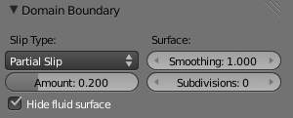
The Domain Boundary panel
This box has all the slip and surface options.
Boundary type
The stickiness of the surface of the obstacle, to determine the “tacky surface (Surface Adhesion).” In the real world, and the tackiness and fluid, the granularity of the object surface, tack, determined by the elasticity.
No Slip
Fluid will stick To snugly (speed 0).
Free Slip
Fluid will move on the object (0 normal direction of speed).
Part Slip
It is a two intermediate. It is almost Noslip, 1 in the Free exactly the same in 0.
Surface
Surface Smoothing
Amount of smoothing to be applied to the fluid surface. 1.0 is standard, 0 is off, while larger values increase the amount of smoothing.
Subdivisions
Allows the creation of high-res surface meshes directly during the simulation (as opposed to doing it afterwards like a subdivision modifier). A value of 1 means no subdivision, and each increase results in one further subdivision of each fluid voxel. The resulting meshes thus quickly become large, and can require large amounts of disk space. Be careful in combination with large smoothing values - this can lead to long computation times due to the surface mesh generation.
Hide fluid surface

Domain Particles
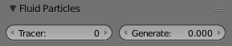
The Domain Particles Panel
Here you can add particles to the fluid simulated, to enhance the visual effect.
Tracer Particles
Number of tracer particles to be put into the fluid at the beginning of the simulation. To display them create another object with the Particle fluid type, explained below, that uses the same bake directory as the domain.
Generate Particles
Controls the amount of fluid particles to create (0=off, 1=normal, >1=more). To use it, you have to have a surface subdivision value of at least 2.
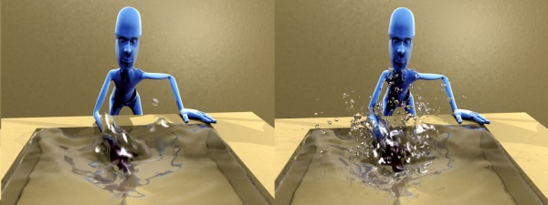
An example of the effect of particles can be seen here - the image to the left was simulated without, and the right one with particles and subdivision enabled.

Fluid Object

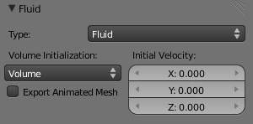
Fluid object settings
All regions of this object that are inside the domain bounding box will be used as actual fluid in the simulation. If you place more than one fluid object inside the domain, they should currently not intersect. Also make sure the surface normals are pointing outwards. In contrast to domain objects, the actual mesh geometry is used for fluid objects.
Volume Initialization Type
See Volume Initialization Type
Animated Mesh/Export
See Animated Mesh/Export
Initial velocity
Speed of the fluid at the beginning of the simulation, in meters per second.
Tip
The direction of Surface Normals makes a big difference!
Bforartists uses the orientation of the Surface Normals to determine what is “inside of” the Fluid object and what is “outside”. You want all of the normals to face outside. If the normals face the wrong way, you’ll be rewarded with a “gigantic flood of water” because Bforartists will think that the volume of the object is outside of its mesh! This applies regardless of the Volume init type setting.

Fluid Obstacle

This object will be used as an obstacle in the simulation. As with a fluid object, obstacle objects currently should not intersect. As for fluid objects, the actual mesh geometry is used for obstacles. For objects with a volume, make sure that the normals of the obstacle are calculated correctly, and radiating properly (use the Flip Normal button, in Edit mode, Mesh Tools panel, Editing context), particularly when using a spinned container. Applying a SubSurf Modifier before baking the simulation could also be a good idea if the mesh is not animated.
Volume Initialization Type
See Volume Initialization Type
Boundary type
Determines the stickiness of the obstacle surface, called “Surface Adhesion”. Surface Adhesion depends in real-world on the fluid and the graininess or friction/adhesion/absorption qualities of the surface.
No Slip
Causes the fluid to stick to the obstacle (zero velocity).
Free Slip
Allows movement along the obstacle (only zero normal velocity).
Part Slip
Mixes both types, with 0 being mostly no slip, and 1 being identical to free slip.
Note that if the mesh is moving, it will be treated as no slip automatically.
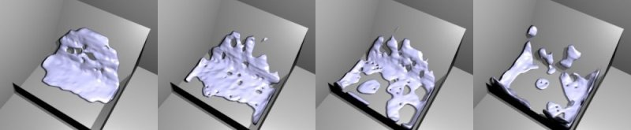
Example of the different boundary types for a drop falling onto the slanted wall. From left to right: no-slip, part-slip 0.3, part-slip 0.7 and free-slip.
Animated Mesh/Export
See Animated Mesh/Export
PartSlip Amount
Amount of mixing between no- and free-slip, described above.
Impact Factor
Amount of fluid volume correction for gain/loss from impacting with moving objects. If this object is not moving, this setting has no effect. However, it if is and the fluid collides with it, a negative value takes volume away from the Domain, and a positive number adds to it. Ranges from -2.0 to 10.0.

Fluid Inflow / Outflow

To control the volume of the fluid simulation, you can set objects in the scene to add or absorb fluid within the Fluid Domain.

Inflow
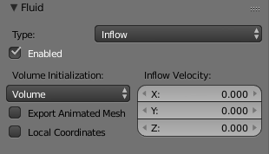
Fluid Inflow Settings
Volume Initialization Type
See Volume Initialization Type
This object will put fluid into the simulation, like a water tap.
Inflow Velocity
Speed of the fluid that is created inside of the object.
Local Coords/Enable
Use local coordinates for the inflow. This is useful if the inflow object is moving or rotating, as the inflow stream will follow/copy that motion. If disabled, the inflow location and direction do not change.
Animated Mesh/Export
See Animated Mesh/Export

Outflow
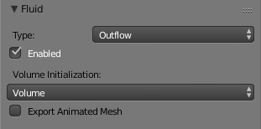
Fluid Outflow Settings
Any fluid that enters the region of this object will be deleted (think of a drain or a black hole). This can be useful in combination with an inflow to prevent the whole domain from filling up. When enabled, this is like a tornado (waterspout) or “wet vac” vacuum cleaner, and the part where the fluid disappears will follow the object as it moves around.
Volume Initialization Type
See Volume Initialization Type
Animated Mesh/Export
See Animated Mesh/Export

Fluid Particle

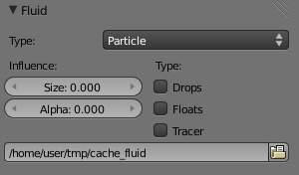
Fluid particle settings
This type can be used to display particles created during the simulation. For now only tracers swimming along with the fluid are supported. Note that the object can have any shape, position or type - once the particle button is pressed, a particle system with the fluid simulation particles will be created for it at the correct position. When moving the original object, it might be necessary to delete the particle system, disable the fluidsim particles, and enable them again. The fluidsim particles are currently also unaffected by any other particle forces or settings.
Influence
Size Influence
The particles can have different sizes, if this value is 0 all are forced to be the same size.
Alpha Influence
If this value is >0, the alpha values of the particles are changed according to their size.
Particle type
Drops
Surface splashes of the fluid result in droplets being strewn about, like fresh water, with low Surface Tension.
Floats
The surface tension of the fluid is higher and the fluid heavier, like cold seawater and soup. Breakaways are clumpier and fall back to the surface faster than Drops, as with high Surface Tension.
Tracer
Droplets follow the surface of the water where it existed, like a fog suspended above previous fluid levels. Use this to see where the fluid level has been.
Path (bake directory)
The simulation run from which to load the particles. This should usually have the same value as the fluid domain object

Fluid Control

Description
Using the Lattice-boltzman method, the fluid is controlled using particles which define local force fields and are generated automatically from either a physical simulation or a sequence of target shapes. At the same time, as much as possible of the natural fluid motion is preserved.

Examples
In this examples, we use the Fluid Control option to control part of the fluid so that it has a certain shape (the sphere drop or the teapot drop) before it falls in the rest of the fluid:
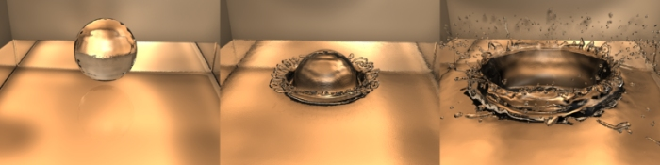
Falling drop

“Magic Fluid Control”

Options
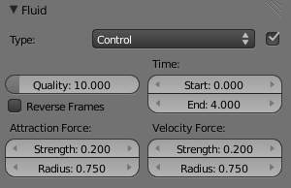
Fluid control options.
Quality
Higher quality result in more control particles for the fluid control object.
Reverse Frames
The control particle movement gets reversed.
Time
You specify the start and end time during which time the fluid control object is active.
Attraction force
The attraction force specifies the force which gets emitted by the fluid control object. Positive force results in attraction of the fluid, negative force in avoidance.
Velocity force
If the fluid control object moves, the resulting velocity can also introduce a force to the fluid.

Baking

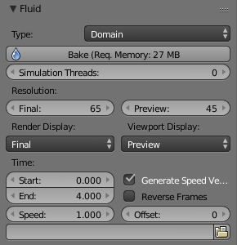
The fluid simulation options with Domain selected

Bake Button
Perform the actual fluid simulation. Bforartists will continue to work normally, except there will be a status bar in the top of the window, next to the render pulldown. Pressing Esc or the “x” next to the status bar will abort the simulation. Afterwards two .bobj.gz (one for the Final quality, one for the Preview quality), plus one .bvel.gz (for the Final quality) will be in the selected output directory for each frame.

Bake directory
Directory and file prefix to store baked surface meshes.
This is similar to the animation output settings, only selecting a file is a bit special: when you select any of the previously generated surface meshes (e.g. test1_fluidsurface_final_0132.bobj.gz), the prefix will be automatically set (test1_ in this example). This way the simulation can be done several times with different settings, and allows quick changes between the different sets of surface data.

Notes
Unique domain
Because of the possibility of spanning and linking between scenes, there can only be one domain in an entire .blend file.
Selecting a Baked Domain
After a domain has been baked, it changes to the fluid mesh. To re-select the domain so that you can bake it again after you have made changes, go to any frame and select (RMB) the fluid mesh. Then you can click the BAKE button again to recompute the fluid flows inside that domain.
Baking always starts at Frame #1
The fluid simulator disregards the Start setting in the Animation panel, it will always bake from frame 1. If you wish the simulation to start later than frame 1, you must key the fluid objects in your domain to be inactive until the frame you desire to start the simulation.
Baking always ends at the End Frame set in the Animation panel
If your frame-rate is 25 frames per second, and ending time is 4.0 seconds, then you should (if your start time is 0) set your animation to end at frame 4.0 × 25 = 100
Freeing the previous baked solutions
Deleting the content of the “Bake” directory is a destructive way to achieve this. Be careful if more than one simulation uses the same bake directory (be sure they use different filenames, or they will overwrite one another)!
Reusing Bakes
Manually entering (or searching for) a previously saved (baked) computational directory and filename mask will switch the fluid flow and mesh deformation to use that which existed during the old bake. Thus, you can re-use baked flows by simply pointing to them in this field.
Baking processing time
Baking takes a lot of compute power (hence time). Depending on the scene, it might be preferable to bake overnight.
If the mesh has modifiers, the rendering settings are used for exporting the mesh to the fluid solver. Depending on the setting, calculation times and memory use might exponentially increase. For example, when using a moving mesh with Subsurf as an obstacle, it might help to decrease simulation time by switching it off, or to a low subdivision level. When the setup/rig is correct, you can always increase settings to yield a more realistic result.

Fluid Appendix

Hints
Some useful hints about fluid simulation in Bforartists:
- Don’t be surprised, but you’ll get whole bunch of mesh (.bobj.gz) files after a simulation. One set for preview, and another for final. Each set has a .gz file for each frame of the animation. Each file contains the simulation result - so you’ll need them.
- Currently these files will not be automatically deleted, so it is a good idea to e.g. create a dedicated directory to keep simulation results. Doing a fluid simulation is similar to clicking the ANIM button - you currently have to take care of organizing the fluid surface meshes in some directory yourself. If you want to stop using the fluid simulation, you can simply delete all the *fluid*.bobj.gz files.
- Before running a high resolution simulation that might take hours, check the overall timing first by doing lower resolution runs.
- Fluid objects must be completely inside the bounding box of the domain object. If not, baking may not work correctly or at all. Fluid and obstacle objects can be meshes with complex geometries. Very thin objects might not appear in the simulation, if the chosen resolution is too coarse to resolve them (increasing it might solve this problem).
- Don’t try to do a complicated scene all at once. Bforartists has a powerful compositor that you can use to combine multiple animations.
For example, to produce an animation showing two separate fluid flows while keeping your domain small, render one .avi using the one flow. Then move the domain and render another .avi with the other flow using an alpha channel (in a separate B&W .avi?). Then, composite both .avi’s using the compositor’s add function. A third .avi is usually the smoke and mist and it is laid on top of everything as well. Add a rain sheet on top of the mist and spray and you’ll have quite a storm brewing! And then lightning flashes, trash blowing around, all as separate animations, compositing the total for a truly spectacular result.

Limitations & Workarounds
- If the setup seems to go wrong, make sure all the normals are correct (hence, enter Edit mode, select all, and recalculate normals once in a while).
- Currently there’s a problem with zero gravity simulation - simply select a very small gravity until this is fixed.
- If an object is initialized as Volume, it has to be closed and have an inner side (a plane won’t work). To use planes, switch to Shell, or extrude the plane.
- Bforartists freezes after clicking BAKE. Pressing Esc makes it work again after a while - this can happen if the resolution is too high and memory is swapped to hard disk, making everything horribly slow. Reducing the resolution should help in this case.
- Bforartists crashes after clicking BAKE - this can happen if the resolution is really high and more than 2GB are allocated, causing Bforartists to crash. Reduce the resolution. Many operating systems limit the total amount of memory that can be allocated by a process, such as Bforartists, even if the machine has more memory installed.
- The meshes should be closed, so if some parts of e.g. a fluid object are not initialized as fluid in the simulation, check that all parts of connected vertices are closed meshes. Unfortunately, the Suzanne (monkey) mesh in Bforartists is not a closed mesh (the eyes are separate).
- If the fluid simulation exits with an error message (stating e.g. that the “init has failed”), make sure you have valid settings for the domain object, e.g. by resetting them to the defaults.
- Note that first frame may well take only a few hundred MBs of RAM memory, but latter ones go over one GB, which may be why your bake fails after awhile. If so, try to bake one frame at the middle or end at full res so you’ll see if it works.
- Memory used doubles when you set surface subdivision from 1 to 2.
- Using “generate particles” will also add memory requirements, as they increase surface area and complexity. Ordinary fluid-sim generated particles probably eat less memory.

